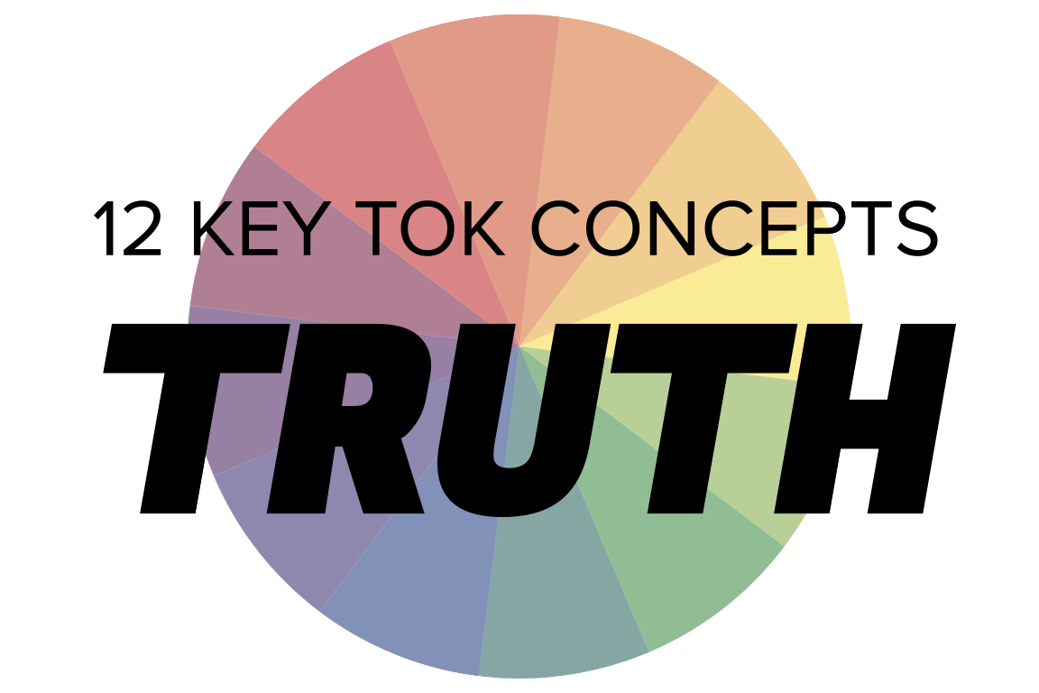 | TRUTH

Understanding the 12 key concepts
- The 12 key concepts are ones that have been identified as having a particular significant relationship to knowledge.
- Understanding, exploring, and using these concepts will help you to understand the way knowledge is produced and used, within the core and optional themes, and the areas of knowledge.
- You should also try to use the key concepts as extensively as possible in the two TOK assessment tasks.
Starting points for truth  - How many online definitions can you find for ‘truth’?  - Which one do you think best sums up this concept, and why?  - Which of the quotes below do you think provides us with the best insight into truth? Are there any you disagree with?  - How many truths about the world would you say you possess? | Quotes on truth  - All things are subject to interpretation whichever interpretation prevails at a given time is a function of power and not truth. Friedrich Nietzsche  - After all, the ultimate goal of all research is not objectivity, but truth. Helene Deutsch  - All truths are easy to understand once they are discovered; the point is to discover them. Galileo Galilei  - Each person does see the world in a different way. There is not a single, unifying, objective truth. We're all limited by our perspective. Siri Hustvedt  - Truth is powerful and it prevails. Sojourner Truth  - If you would be a real seeker after truth, it is necessary that at least once in your life you doubt, as far as possible, all things. Rene Descartes
Interlinking the key concepts  - Is truth the same as certainty?  - Does truth vary between cultures?  - Can truth be proven with evidence?  - Do we all have a responsibility to search for the truth about the world?  - Are our values based on truths? | Relating truth to the TOK course  - In which of the areas of knowledge is it easiest to access the truth?  - Is mathematics the only area of knowledge that deals with truth?  - Has the development of technology allowed us to access the truth more easily?  - Does language help or hinder us from accessing the truth about the world?  - Do indigenous societies have a different concept of truth to large-scale society?
Relating truth to the TOK exhibition  - IAP-1: Think about whether truth and knowledge are synonymous  - IAP-18: Think about whether some things are unknowable  - IAP-25: Think about the role of truth in discerning between knowledge, belief, and opinion  - IAP-33: Think about whether we get closer to the truth over time | Relating truth to the Big Questions  - BQ1 - What do we mean by truth when it comes to knowledge about the world?  - BQ2 - Do our values depend on knowing the truth about the world?  - BQ3 - Does the fact that there are multiple ways of communicating knowledge mean truth does not exist?  - BQ4 - Is truth dependent on our perspective?  - BQ5 - How does our concept of truth change over time?  - BQ6 - Do expert knowers possess the truth about the world?

Real-world contexts for truth
The media sources below explicitly mention truth (or true), and discuss this key concept in a real-world context. Use the find command (ie Command/Control+F) to locate the term in the article or transcript of the video, and you’ll see where it features. Check back regularly, as we update these media sources every month.
Big Question / knowledge framework | Description of media source and story and links to the course
BQ1 / Nature & scope | A Big Think article, discussing how quantum entanglement indicates that uncertainty is built into the structure of the Universe. Natural sciences, Mathematics, Technology  A Big Think article, analyzing how our sense of self is defined by mirrors and video calls, and why this undermines our self-awareness. Knowledge & the knower, Technology  A Big Think article, which considers whether we rely on scientific conclusions even when they cannot be proven. Natural sciences, Human sciences  A New Humanist article, looking how we often base our perception of truth on facial expressions, even in court. Language, Knowledge & the knower, Human sciences  An FT article, considering the difficulties of linking extreme weather to climate change, in the wake of the fires and floods that have recently affected countries around the world. Natural sciences, Technology, Mathematics, Politics, Knowledge & the knower  A Big Think article, which draws on the ideas of Kurt Gödel, and thinks about whether mathematics is built on unproven foundations. Mathematics, language  A Guardian discussion between a doctor and a former rugby player, on the evidence that contact sports can cause permanent brain damage. Natural sciences  A Big Think article, in which Donald Hoffman argues we have evolved to experience a “collective delusion”. Knowledge & the knower, human sciences  An Aeon essay that looks at the pragmatic theory of truth, and evaluates its usefulness in helping us produce knowledge. Knowledge & the knower, human sciences  A Big Think video, looking at why we evolved religious thinking, and how religion and science have very different purposes. Natural sciences, religion  A Guardian article, criticizing the Netflix series ‘The Crown’ for being “as corrosive as fake news.” History  A Big Think article, which considers which matters more to Christian belief: the physical reality of Jesus, the message he communicated. Religion
BQ2 / Values | A Conversation article, focusing on the struggle of native Americans for control over their sacred land. Indigenous societies, Religion  A DW article and accompanying videos, considering the ethical questions thrown up by the ‘era of genetics’. Natural sciences, Human sciences  An Guardian article, looking at a recent study that concluded The Boy in the Striped Pyjamas could fuel dangerous holocaust fallacies. History, The arts  A Guardian article, focusing on a forensic psychiatrist, and her thoughts on the role of ‘radical empathy’ in order to understand the human condition. Human sciences, Knowledge & the knower  An Art Newspaper article, discussing the importance of facing up to the complete histories of monuments and buildings, even when they are morally murky. History, language  A Conversation article, considering the work of Nawal El Saadawi, a writer, physician, and activist who had a huge influence on the way we think.  The philosopher Daniel DeNicola argues in Aeon that we don’t have the freedom to believe in what we choose; our beliefs must be supported by valid evidence. Knowledge & the knower, human sciences  A Vox podcast, thinking about how Albert Camus’s novel ‘The Plague’ offers a model of what’s happening in the world today. The arts, language  Lin-Manuel Miranda, the composer, playwright, and actor, discusses in The Atlantic the purpose of art, and what role artists should play in society. The arts  A History Today article, which challenges the common historical perception of Vikings as being ‘racially pure’ and culturally homogenous, pointing out that the evidence seems to indicate that they were “cultural chameleons adopting local habits, languages and religions.” History, human sciences, knowledge & the knower  This is a Vox interview with Patricia Churchland, a ‘neurophilosopher’ who specializes in how biological evolution impacted on our intuitive ability to distinguish right from wrong. Human sciences, natural sciences
BQ3 / Methods & tools | A Conversation article, analyzing the effect of misinformation on the way we view and try to manage pandemics. Natural sciences, Human sciences, Technology, Knowledge & the knower  A CNN article, looking at how a group of teachers from Texas considered reterming ‘slave trade’ as ‘involuntary relocation’. History, Language, Politics, Human sciences  A Smithsonian article, looking at a 1945 Holocaust comic that tried to communicate the horrors of the Nazi death camps. Language, History, The arts, Knowledge & the knower  A Slate article, using the 50th anniversary of the photo of the ‘Napalm Girl’ to explore the impact of memorable images. The arts, History, Technology, Knowledge & the knower, Politics  A Moscow Times report on how the words ‘war’ and ‘invasion’ have been banned by the Russian authorities. Language, Politics, Knowledge & the knower, History  A Wired article, looking at the use of TikTok during the Russian invasion of Ukraine. Technology, Language, Human sciences  A Vox podcast and article, considering whether Putin will be able to continue manufacturing reality as the loss of life in the Ukraine caused by his invasion mounts. Human sciences, Technology, History, Language  A CNN article, looking at the launch of Donald Trump’s new social media app, ‘Truth Social’. Technology, Language, Politics  A Guardian video, considering why conspiracy theories are so attractive to us as an explanation of how the world functions. Knowledge & the knower, politics, technology  A Smithsonian article, exploring the historical usefulness and accuracy of the film 1917. History, the arts
BQ4 / Perspectives | A Guardian article, exploring the way The Onion’s satire has developed over the past few years, and what this tells us about society. Politics, The arts, Knowledge & the knower, Human sciences  A BBC article, considering whether Bolivia’s high proportion of female lawmakers can inspire political change elsewhere in the world. Politics, Human sciences, Knowledge & the knower  A Guardian article, considering Judi Dench’s demand that Netflix include a disclaimer in each episode of The Crown stating that it is fictional. The arts, History  A Salon article, arguing that the term ‘feminist science’ is not an oxymoron, and offers a powerful set of tools for examining knowledge. Natural sciences, Knowledge & the knower, Politics  A New Statesman article, which argues that the James Webb images offer us a route towards political and social unity. Natural sciences, Politics, Human sciences  A Conversation article, looking at how cognitive biases and brain biology prevent us from changing our minds, even when the facts contradict our beliefs. Knowledge & the knower, Human sciences  A New Statesman article, exploring how audiences hear two different stories when they watch the congressional hearings about the Capitol Hill riots. Politics, Knowledge & the knower  A Conversation article, looking at why some people are asserting that Bitcoin is similar to a religion. Religion, Human sciences, Knowledge & the knower  A History Today article, looking at how the conflict between Russia and Ukraine is as much about the past as it is about the present. History, Politics  An FT article, looking at demands from workers that algorithms used to make decisions by gig economy companies are made more transparent. Technology, Human sciences  A Conversation article, looking at how our judgement of when life begins is as much a matter of politics as it is about science. Politics, Natural sciences, Religion, Human sciences  A Guardian article about how the author of a recent race report wanted to introduce a single historical textbook into schools in the UK conveying ‘the’ truth about the past. History  A Scientific American article, asserting that smart people are vulnerable to putting ‘tribe before truth’ when it comes to understanding the world. Natural sciences, knowledge & the knower  This Guardian video looks at the people around the world who genuinely believe that the earth is flat. Rather than passing judgement, it attempts to understand why they hold this belief. Knowledge & the knower, natural sciences  As it explains in the introduction, this Aeon essay is all about discerning what you really believe, from the ideas that you might have for other motives. It offers some truth experiments to help identify your ‘true’ beliefs. Knowledge & the knower, politics, religion  This Guardian article considers how denial about the facts of the Srebrenica massacre are gaining ground. History, politics, language  A Big Think article, looking at the YouTube documentary, ‘'Plandemic', and how it is defined by its anti-vax agenda. Natural sciences, human sciences, politics
BQ5 / Methods & tools | A New Humanist article, considering whether psychology is “the superstition of our age”. Human sciences, Knowledge & the knower, Religion  A Met video, exploring the way in which Greek and Roman sculptures were very different from the way we see them today. The arts, History  A Slate article, considering why computers on their own can’t generate random numbers, and the methods used to overcome this problem. Technology, Mathematics, Politics  An Atlantic article that explores the increasing extent to which the Internet is an unreliable depository of knowledge, as ‘content drift’ and ‘link rot’ become endemic. Technology, Knowledge & the knower  A Big Think article which applies a thoughts experiment from the 1970s to the modern world - with insightful results. Knowledge & the knower, technology  A History Today article, which explores how filling in the historical gaps about the past “requires the techniques of a novelist”. History, the arts, knowledge & the knower  A Boston Review article, looking at the rise and fall - and rise again - of epistemology is linked to the way digital media has taken over society. Human sciences, technology, politics  A Smithsonian article, which looks at how knowledge about the natural world within industrialized, large scale societies often takes its lead from what indigenous societies already know, despite being skeptical about the validity of indigenous knowledge. Indigenous societies, Knowledge & the knower, natural sciences  This BBC article thinks about how words change over time, and how certain terms help to reflect the reality of contemporary society. Language, human sciences, politics  An Aeon essay, considering how the Aztec people approached history, and how for them, truth was ‘composite’. History, indigenous societies, language  Vladimir Kara-Murza (who happens to be an ex-student of Michael Dunn!) considers in the Washington Post why the Soviet-Afghan war is being ‘revised’ by the current Russian government, and viewed in a different light. History, politics
BQ6 / Methods & tools | A Vox podcast and interview with Neil deGrasse Tyson, in which he discusses how many people are unable to distinguish between fact and opinion. Knowledge & the knower, Natural sciences, Human sciences, anything, really!  A Wired article, investigating the phenomenon of ‘body language pseudoscience’ on YouTube, and its increasing prevalence. Language, Human sciences  A Conversation article, arguing that the exposure of a faked study shows the strength, not the flaws, of behavioural science. Human sciences  An FT article, looking at the importance of protecting ‘truth tellers’ in society, and facing up to facts about the world. Human sciences, natural sciences, mathematics, politics, technology  A Big Think article, looking at how Francis Bacon - 400 years ago - identified ‘cognitive biases’ and offered advice on how to overcome them. Knowledge & the knower, language  An Independent article, reporting on how two hoaxers persuaded four ‘royal experts’ to comment on the Meghan Markle/Oprah Winfrey interview - before they’d actually seen the interview. Human sciences, politics  A Guardian conversation between John Banville and John Le Carré, reprinted on the day of the latter’s death. The arts, politics, language, history  A Now and Then video, looking at the extent to which we can - and should - apply objectivity to our study of the past. History, the arts, language  This is a New Statesman article by the great-grand-daughter of EH Carr, one of the most influential historians of the last 20th century. It discusses his approach to this area of knowledge, and what he believed the purpose of history - and the historian - was. History, knowledge & the knower  This attractive Massive/Aeon video outlines the life and work of Grete Hermann, who was a mathematician and philosopher, who offered an interesting insight into the discoveries of the earliest quantum physicists. Natural sciences, mathematics  This is a Guardian video that looks at the people around the world who genuinely believe that the earth is flat. Rather than passing judgement, it attempts to understand why they hold this belief. Natural sciences, human sciences, knowledge & the knower  This Aeon essay by Massimo Pigliucci looks at Richard Feynman’s belief that truth in physics is something that correlates to elegance and beauty. Natural sciences, mathematics, knowledge & the knower  A Guardian article, considering the opinions of those who hold ‘anti-science’ views, such as the idea that vaccinations are harmful to our health, and the earth is flat. It links this to the way in which science is sometimes communicated with a lack of empathy. Natural sciences, human sciences, knowledge & the knower

